EXPERIMENT – 3
Create a simple cloud software application for Property Buying & Rental process (In Chennai city) using any Cloud Service Provider to demonstrate SaaS.
AIM: To create and provide a simple cloud-based software application for Property Buying & Rental process (In Chennai city) using Zoho Creator to demonstrate the Software as a Service (SaaS) model.
PROCEDURE:
- Open a web browser and go to Zoho Creator website.
- Create a Zoho account and log in.
- Click on Create Application and select From Scratch.
- Choose Blank App and provide the application name as Buy or Rent a property.
- Create a form named User Details and add fields such as Name, Phone and Email.
- Create another form named Buy or Rent and add fields such as Looking to, Preferred Area in Chennai, Maximum Price, Number of People and Host Type.
- Mark the necessary fields as mandatory.
- Save the completed form and alter the visual themes.
- Configure user access and sharing settings to allow multiple users to use the application.
- Save the application and generate the application URL.
- Access the application through the URL using any web browser.
OUTPUT:
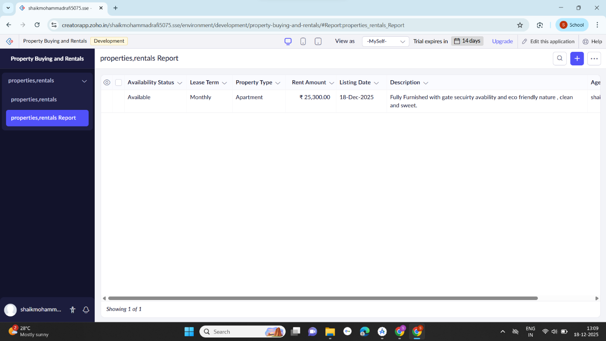

RESULT:
A cloud-based Property Buying & Rental process (In Chennai city) application was successfully created and deployed using Zoho Creator. The application is accessible through a web browser without installation, and users can Sign up and Register to find a property, thereby successfully demonstrating the Software as a Service (SaaS) model.

